|  |  |
| --- | --- |
| **Hotel Booking** | Abstract  This report presents a comprehensive analysis of hotel booking cancellations, shedding light on the multifaceted challenges and opportunities that they pose to the hospitality industry. The study explores the intricate web of factors leading to booking cancellations, ranging from customer behavior and external influences to hotel policies and strategies.  aarusharma27december@gmail.com  Data Analyst |

**Buisness Problem**

In recent years, City hotel and Resort Hotel have seen high cancellation rates. Each hotel is not dealing with the number of issues as a result including fewer revenues and less than ideal hotel room use. Consequently lowering cancellation rates is both hotels primary goal in order to increase their efficiency in generating revenue, and for us to offer through business advise to address this problem.

The analysis of hotel booking cancellations as well as other factors that no have no bearing on their business and yearly revenue generation are the main topics of this report.

**Assumptions**

* No unusual occurrences between 2015 and 2017 will have a substantial impact on the data used.
* The information is still current and can be used to analyse a hotel 's possible plans in an efficient manner.
* They are no unanticipated negatives to the hotel employing any advice technique.
* The hotels are not currently using any of the suggested solutions.
* The biggest factor affecting the effectiveness of earning income is booking cancellations.
* Cancellations result in vacant rooms for the book length of time.
* Clients make hotel reservations the same year they make cancellations.

**Research Question**

* What are the variables that affect Hotel reservation cancellations?
* How can we make hotel reservations cancellation better?
* How will hotels be assisted in making pricing and promotional decision?

**Hypothesis**

* More cancellations occur when prices are higher.
* When there is no longer waiting list , customer tend to cancel more frequently .
* The majority of clients are coming from offline travel agents to make their reservations.

**Analysis and Findings**

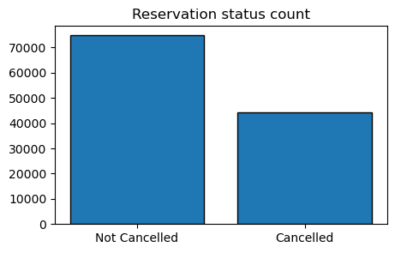

The accompany bar graph shows the percentage of reservations that are cancel and those that are not. It is obvious that there are still a significant number of reservation that have not been canceled. They are still 37% of client who cancel their reservation, which has a significant impact on the hotel 's earnings.

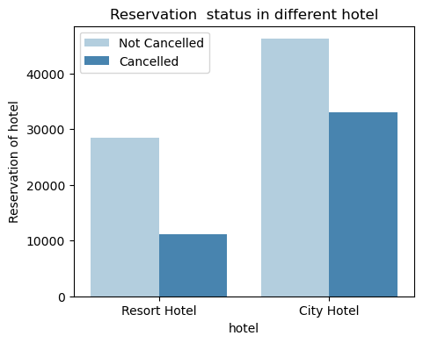

In comparison to resort hotels , city hotel have more bookings. It 's possible that resort hotels are more expensive than those in cities.

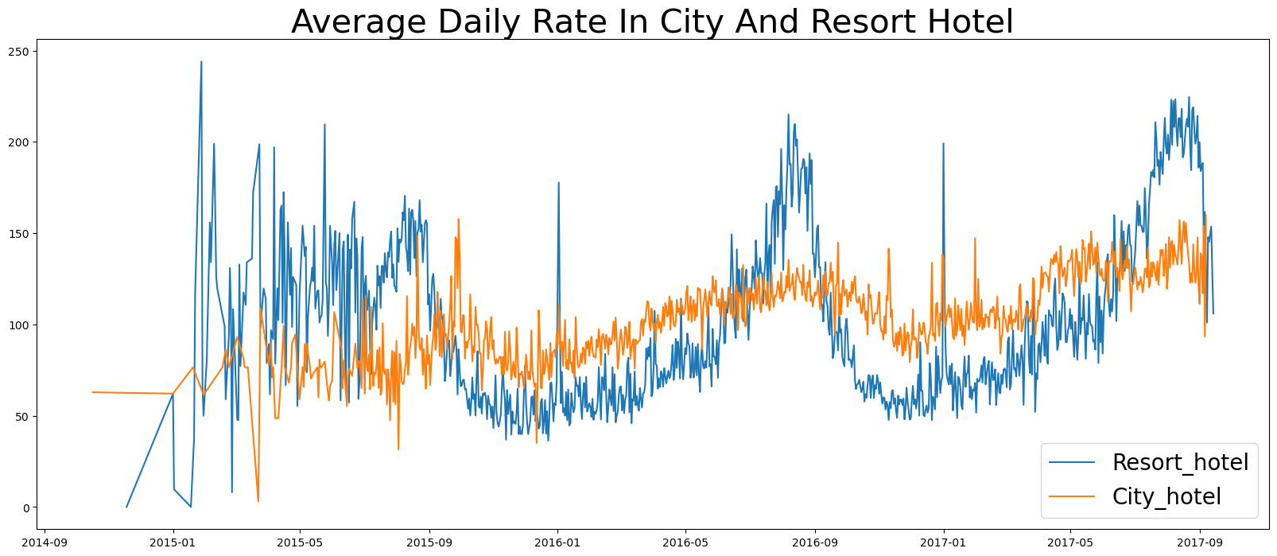

The line graph above shows that on certain days, the average daily rate for a city hotel is less than that of a resort hotel and on other days , it is even less . It goes without saying that weekends and holidays may see a rise in resort hotel rates.

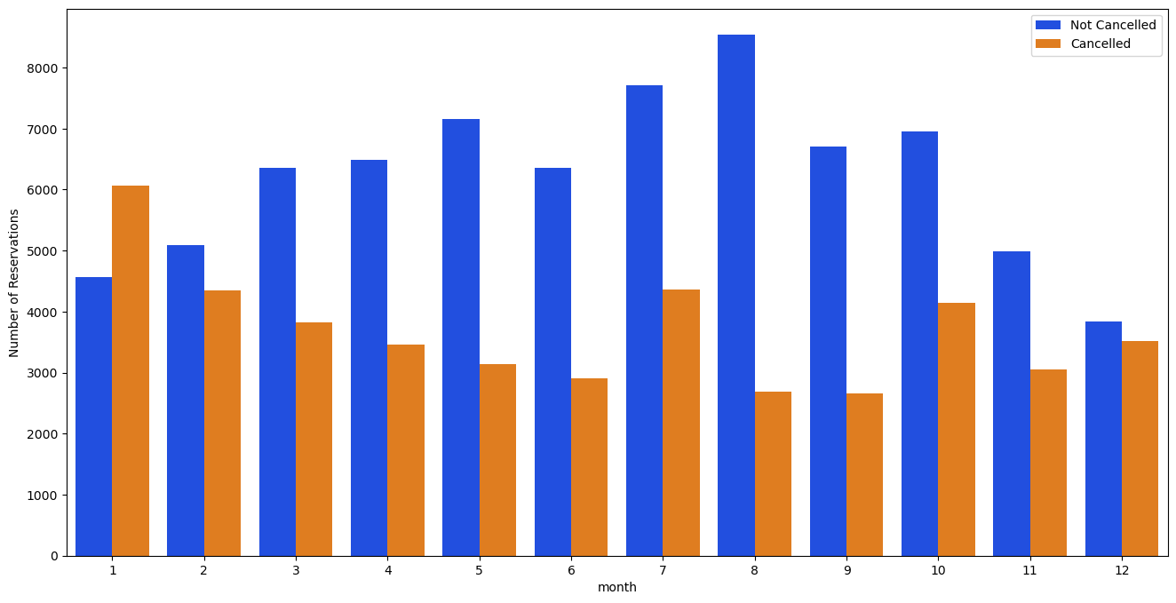

We have developed that the group bar graph to analyze the months with the highest and lowest reservation levels according to reservation status.

As can we seen, both the number of confirmed reservations and the number of canceled reservations are largest in the month of August, whereas January is the month with the most canceled reservations.

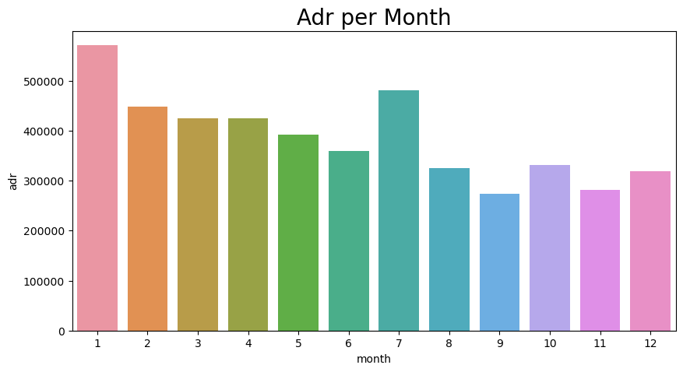

The bar graph demonstrate that cancellations are most common when prices are greatest least common when they are lowest . Therefore, the cost of the accommodation is society responsible for the cancellation.

Now, let's see which country has the highest reservation canceled. The top country is Portugal with the highest number of cancellations.

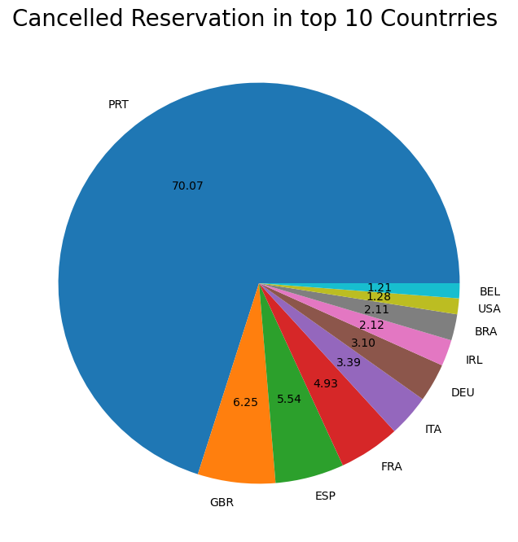

Let's check the area from where guests are visiting the hotels and making reservations. Is it coming from Direct or Groups , Online aur Offline travel Agents? 46% of the clients come from online travel agencies, whereas 27% come from groups. Only 4% of clients book hotels directly by visiting them and making reservations.

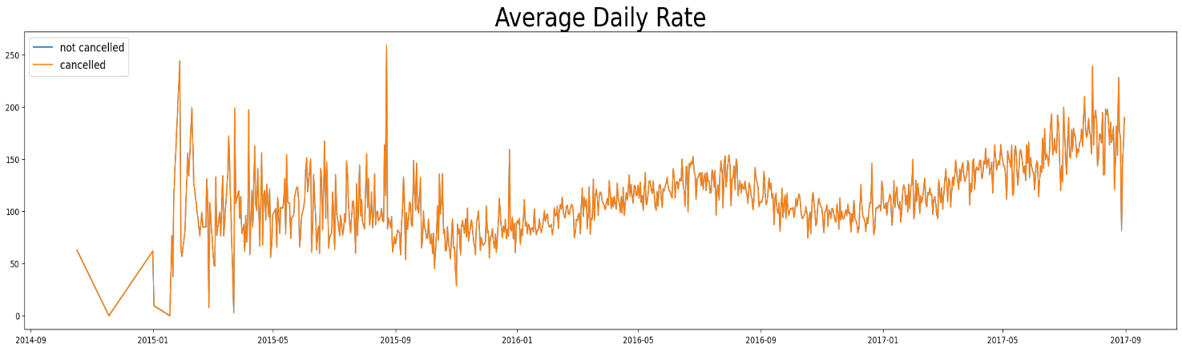

As seen in the graph , reservations are cancelled when the average daily rate is higher then when it is not cancelled. It clearly proves all the above analysis , that the higher price leads to higher cancellation.

**Suggestions**

* Cancellation rates rise as the price does. In order to prevent cancellations of reservations, hotels could work on their pricing strategies and try to lower the rate for specific hotels based on locations. They can provide some discount to the consumers.
* As the ratio of the cancellation and not cancellation of the resort hotel is higher in the resort hotel then the city hotels. So the hotels should provide a reasonable discount on the room prices on weekends or on holidays.
* In the month of January, hotels can start campaigns or marketing with the reasonable amount to increase the revenue as the cancellation is the highest in this month.
* They can also increase the quality of their hotels and their services mainly in Portugal to reduce the cancellation rate.